Network Cabinet Accessories

Description
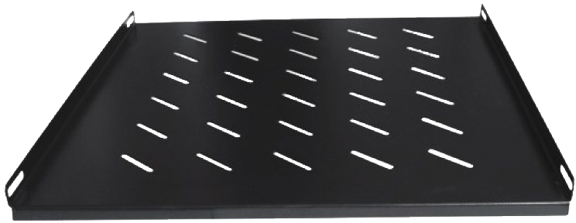

1U,19" Fixed Shelf

Overview

VisionNet 19’’ Fixed shelf is the ideal solution for placing equipment's that are non-19’’ or not suitable to install into the rack cabinet. It is designed to fit virtually any 19-inch server rack and can accommodate for data, IT, networking or other non-rack mount equipment. Fixed Shelves are selected according to the depth of rack cabinet and they make the cabinets more organized.

Key Features

- SPCC Cold Rolled Steel Body 1.2mm Thickness.
- 19''Installation.
- Vented Holes for Ventilation.
- Certificates: CE, RoHS.
- Surface Finish: Degreasing, pickling, phosphating, powder coating.
- Body color: RAL9004(Black) or other colors for options.

PART NO | w(MM) | D(MM) | H(U)
 | 482 | 345 | 1U
198784 | 482 | 525 | 1U
 | 482 | 700 | 1U

